This project contains good features which are required in all project which are developed in industries nowadays. Let’s see what is this project all about, this project is a basic gym project which has 2 modules in it

1. Admin end
2. User end

**Admin end**

Let’s start with admin end first in this part admin has all right of applications master such as adding Users, Role, Scheme, Plan, and various reports such as month wise income and year wise income reports, all member reports and also has a renewal report which shows how much renewal are there for period admin choose.

**User end**

If you see User end where a User is a person who does work of registration of new members and collecting payment of membership. The user has limited access such user can register a new member and renew membership and see payment details of the member along with renewal date.

The project has 2 parts

1. ASP.NET Core with Angular CLI
2. SQL server for database parts

### Login Admin

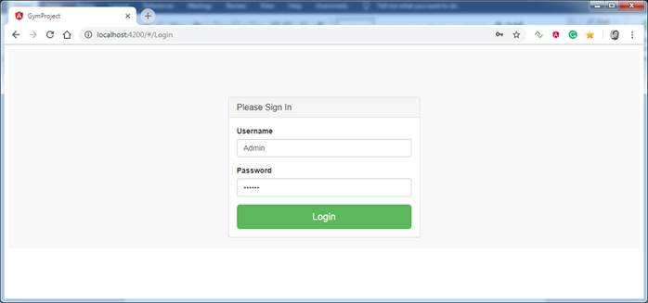

### Admin View

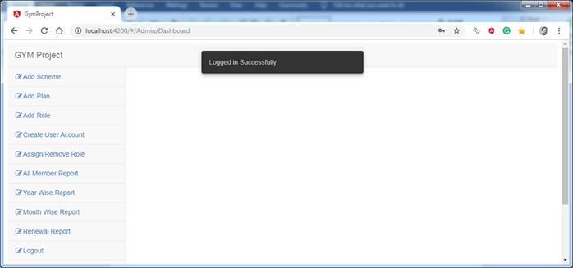

### User View

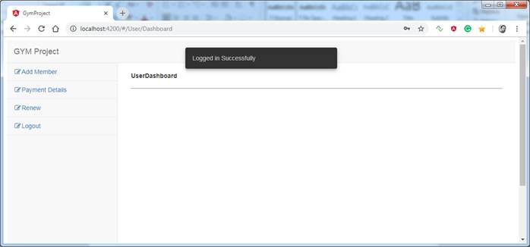

### Add Member

